**SNACKS CENTRE ONLINE DELIVERY SYSTEM**

**Software Requirements Specification (SRS) Document**

**Sprint Implementation**

**Project Timeline: 19-10-2022 to 27-10-2022**

|  |  |
| --- | --- |
| **TITLE** | **PAGE** |
| INTRODUCTION | 2 |
| USE CASE DIAGRM | 3 |
| ENTIRE FLOW OF THE PROJECT(REPRESENTATION) | 4 |
| FUNCTIONALITIES | 5 |
| COMPONENTS | 6 |
| WORKING | 7,8 |
| PROJECT FEATURES AND REQUIREMENTS | 9 |

**Project Introduction:**

* + - The purpose of this project is to implement a snacks center delivery system. Allows customers to view the Admin user and then exit by choosing admin it asks for the user name and password and we can successfully login into the snacks center page. And after login successfully to the account it displays the menu details. By clicking the user it shows the menu list of the user.
    - Then prepares the customers order and delivers the order to customer if the items and distance should be beyond the limit.

**Flow Diagram of Snacks Centre Application:**

**User Case Diagram**

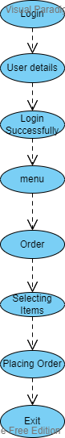

**ENTIRE FLOW OF THE PROJECT**

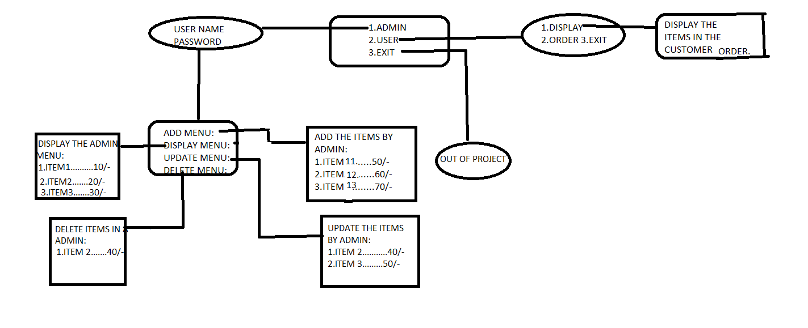

**Application Functions :-**

* + - * There is a two-way communication between different admin and user.
      * This snacks centre application can be used for online delivery system.
      * User details can be used by the admin and deliver the order to the users based upon the conditions of admin.
      * Based upon the stock available at the admin side and the distance between the snacks centre and user should be below 10 kms then only order is confirmed.

**Functionalities :-**

**For User Login**

The user must login by giving details like user name and the password. After login successfully into the snacks centre page it displays the details related to menu like add menu, display menu, update menu, delete menu, exit.

**Failure Login**

If the user is missed to give the details like name and password then the process will stops up-to there. We can not able to move further process.

**Admin Validation For User**

The user want to give the name and the password based up-on the login details the admin can validates the account of the user and procced to place the order. And the order ID will be also considered.

**Communication Exchange**

The owner can see the order details and then the owner can accept the order and if the customers order up-to 3 items and below the 10 kms then the owner confirms the customers order.

**Components used in the Project : -**

1. **User side**
   1. The customer register into the snacks centre page by giving the details.
   2. The customer view the menu and place an order.
   3. The customer can see the order if the order is confirmed.
2. **Admin side**

1.If the distance of the customer would be less than 10kms.

2.The admin can see the details the like username and password.

3.And also checks the details of the customer menu list. If the customer is missed to give the mobile number and name then owner cannot accept the order.

4.After login successfully it asks for add menu display update delete and exit.

5.And then the admin will displays the add menu, display menu, update menu, delete menu, exit.

**User side working: -**

**Validation process**

The customer should give the details like user name and password distance form customer’s location to the snacks centre. If the any of the customer details are not given or the distance limit is more than we are unable to place the order.

**Placing an order**

Placing an order can be done after the login details given. The order can be accepted by the admin by seeing the display menu of the user. If the user updated the menu then the admin automatically change the items and it delivers to the customers location.

**Confirmation of order to the customer**

After placing the order the customer can be able to delete the order. The owner can accept the cancellation of the customers order. After placing an order the owner can generate the order ID for the customer’s order.

**Admin side working:-**

**1.verify the user details**

If the admin can be able to see the details of the user. In the registration details the name and the password is must be given, if the customer doesn’t give details properly then the owner can not accept the account.

**2.Cancellation of orders**

Once the customer is placed the order the customer is able to delete the order. The cancellation of order can be accepted by the owner.

**3.Acceptance of orders**

The orders should be successfully delivers if the order is less than or equal to the 3 items and the distance limit is below the 10 kms then the order should be delivered successfully. Acceptance of order should be considered as the conditions of the owner should must be accepted by the customer. The acceptance of the order can be done generating the order ID.

**Project Features**

The food ordering management system has following features

1. Order foods from the menu.

2. Login as admin

3. Add food items

4. Delete food items

5. Edit food menu

6. View current food menu

7. View current food order

**System Requirements:-**

**Software Requirements:**

* Works on Windows 10 (64-bit)
* Operating System : Cygwin version 20.04.4
* Compiler: gcc (Cygwin)
* Code developed using the concept of DMA in C
* Customer owner delivery management System
* Tools: valgrind, makefile.

**Hardware Requirements:**

* For the Windows
* RAM Allocated: 4 GB
* Hard disk Size: 250 GB
* Microprocessor: 2 GHz